# Project Planning Phase

**Project Planning Template (Product Backlog, Sprint Planning, Stories, Story points)**

|  |  |
| --- | --- |
| Date | 21th july , 2025 |
| Team ID | LTVIP2025TMID30092 |
| Project Name | TrafficTelligence : Advanced Traffic Volume Estimation with Machine Learning |
| Maximum Marks | 20 Marks |

Product Backlog, Sprint Schedule, and Estimation (4 Marks)

Use the below template to create product backlog and sprint schedule

|  |  |  |  |  |  |  |
| --- | --- | --- | --- | --- | --- | --- |
| **Sprint** | **Functional Requirement (Epic)** | **User Story Number** | **User Story / Task** | **Story Points** | **Priority** | **Team Members** |
| Sprint-1 | Project setup &  Infrastructure | USN-1 | Set up the development environment with the required tools and  frameworks to start the project | 1 | High | Naga Sashank |
| Sprint-2 | Data collection | USN-2 | Gather a diverse dataset of Date, time, holidays and climatic conditions. | 2 | High | Naga Sashank |
| Sprint-2 | data preprocessing | USN-3 | Preprocess the collected dataset by removing outliers and null values etc. Explore and evaluate different deep learning architectures (e.g., Regressions) to select the most suitable model for the project. | 3 | High | Kiran Achari |
| Sprint-3 | model development | USN-4 | train the selected machine learning model using the preprocessed  dataset and monitor its performance on the validation set. | 4 | High | Kiran Achari |
| Sprint-3 | Training | USN-5 | The data set will be trained with suitable algorithms to improve the robustness and accuracy. | 6 | medium | Sunil Kumar |
| Sprint-4 | model deployment & Integration | USN-6 | deploy the trained machine learning model as a web service to make it accessible for users. Integrate the model's API into a user-friendly web interface for users to input variables such as date, time, holidays etc and receive predicted volume results. | 1 | medium | Sunil Kumar |
| Sprint-5 | Testing & quality assurance | USN-7 | conduct thorough testing of the model and web interface to identify and report any issues or bugs. fine-tune the model hyperparameters and optimize its performance based on user feedback and testing results. | 1 | medium | Gopi |

Project Tracker, Velocity & Burndown Chart: (4 Marks)

|  |  |  |  |  |  |  |
| --- | --- | --- | --- | --- | --- | --- |
| **Sprint** | **Total Story Points** | **Duration** | **Sprint Start Date** | **Sprint End Date (Planned)** | **Story Points Completed (as on Planned End Date)** | **Sprint Release Date (Actual)** |
| Sprint-1 | 1 | 3 Days | 3 Nov 2023 | 6 Nov 2023 | 1 | 6 Nov 2023 |
| Sprint-2 | 5 | 2 Days | 6 Nov 2023 | 8 Nov 2023 | 5 | 8 Nov 2023 |
| Sprint-3 | 10 | 5 Days | 8 Nov 2023 | 13 Nov 2023 | 10 | 13 Nov 2023 |
| Sprint-4 | 1 | 5 Days | 13 Nov 2023 | 18 Nov 2023 | 1 | 20 Nov 2023 |
| Sprint-5 | 1 | 4 Days | 18 Nov 2023 | 22 Nov 2023 | 1 | 21 Nov 2023 |

Velocity:

Imagine we have a 29-days sprint duration, and the velocity of the team is 20 (points per sprint). Let’s calculate the team’s average velocity (AV) per iteration unit (story points per day)

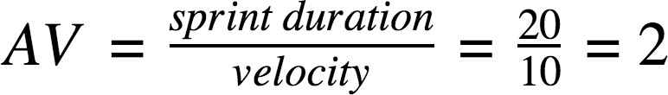

# AV= 19/3.8 = 5

Burndown Chart:

A burndown chart is a graphical representation of work left to do versus time. It is often used in agile software development methodologies such as Scrum. However, burn down charts can be applied to any project containing measurable progress over time.

https://www.visual-paradigm.com/scrum/scrum-burndown-chart/ https://www.atlassian.com/agile/tutorials/burndown-charts

Reference:

**https://www.atlassian.com/agile/project-management https://www.atlassian.com/agile/tutorials/how-to-do-scrum-with-jira-software https://www.atlassian.com/agile/tutorials/epics https://www.atlassian.com/agile/tutorials/sprints https://www.atlassian.com/agile/project-management/estimation https://www.atlassian.com/agile/tutorials/burndown-charts**

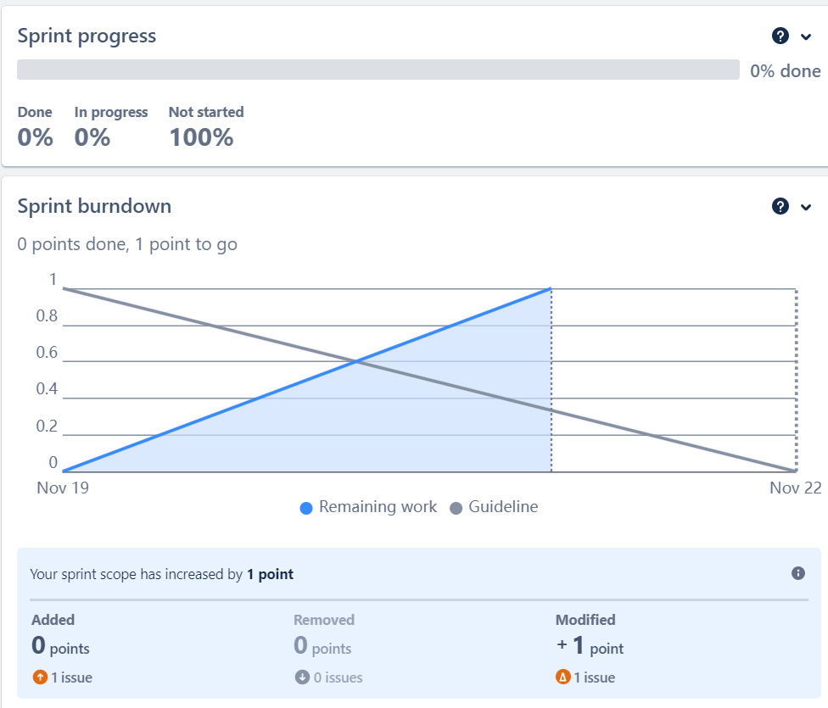Burndown Chart: For the 5th Sprint

Board section.

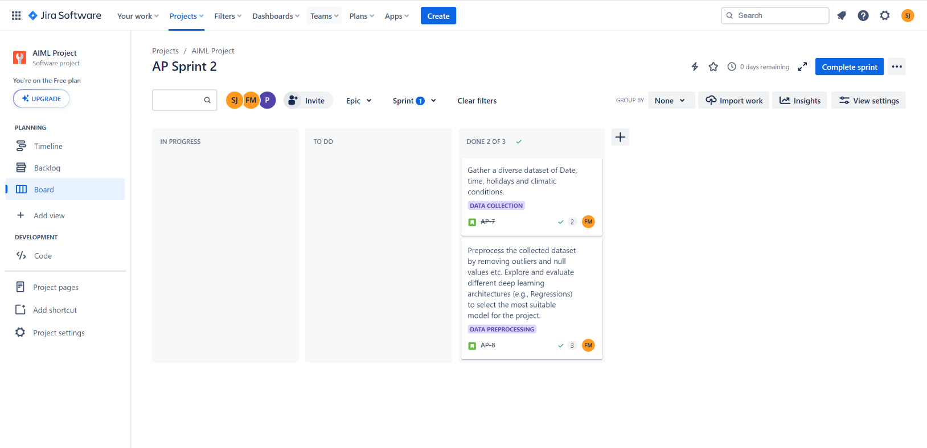We have completed till sprint 2.

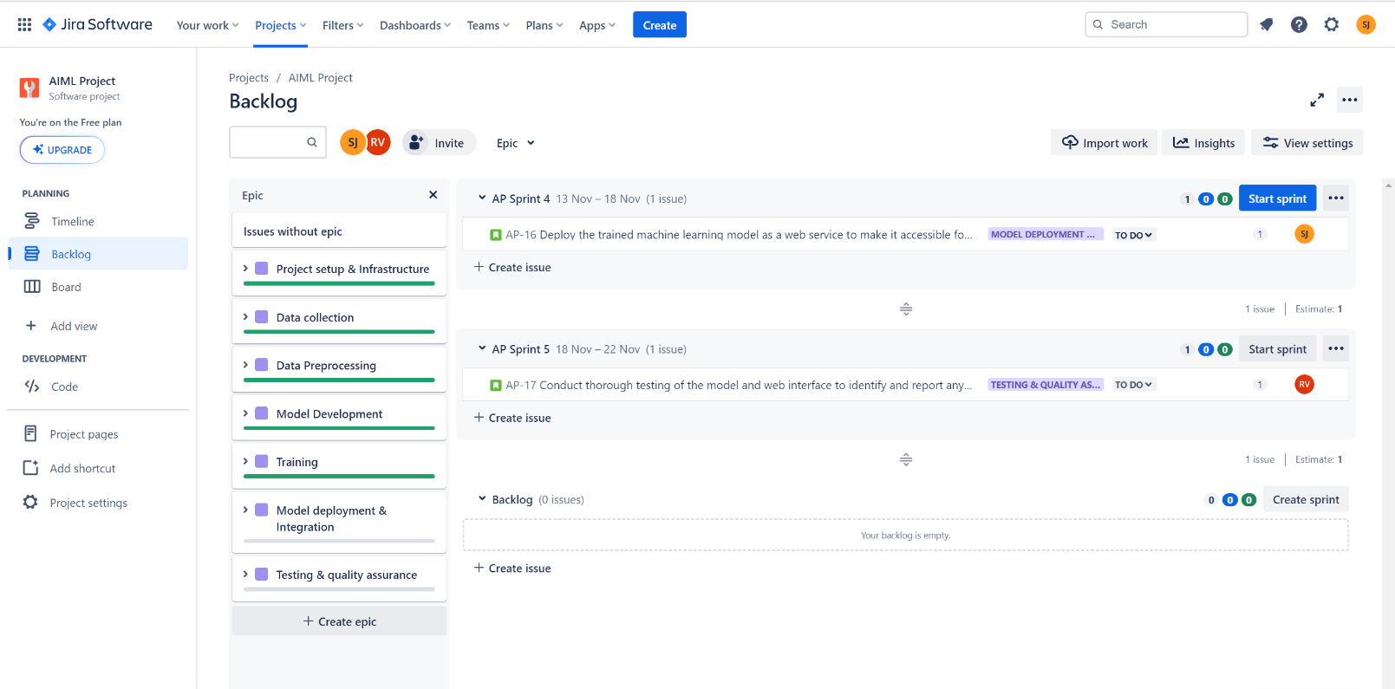Backlog section

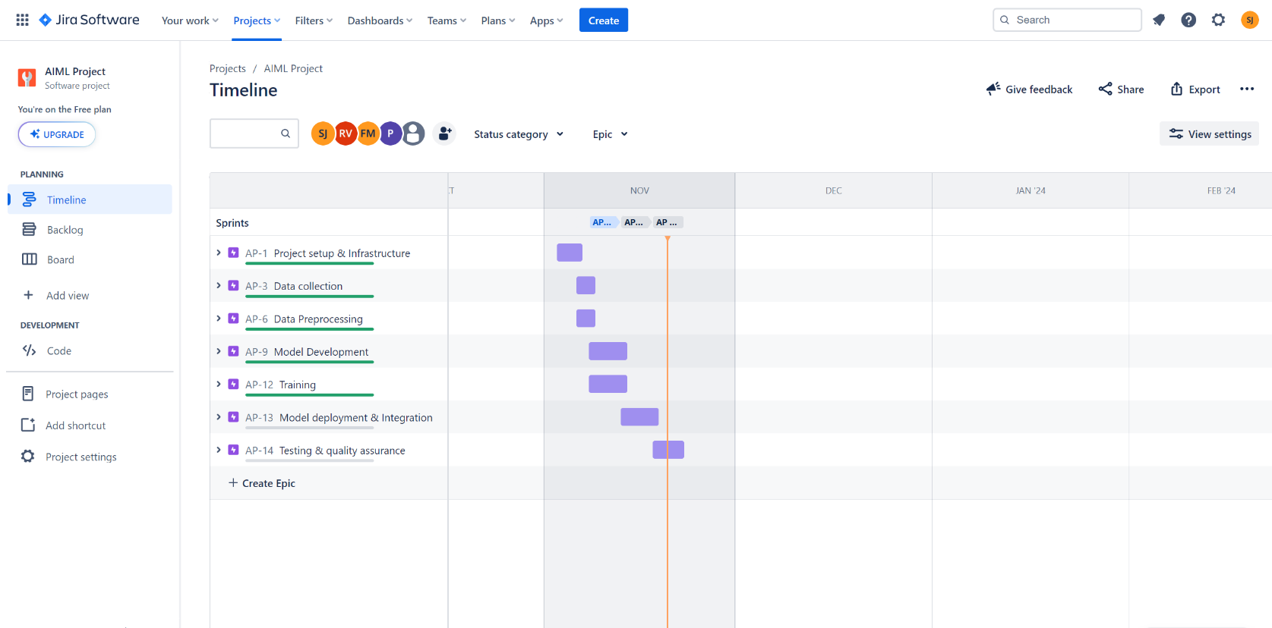**Timeline**